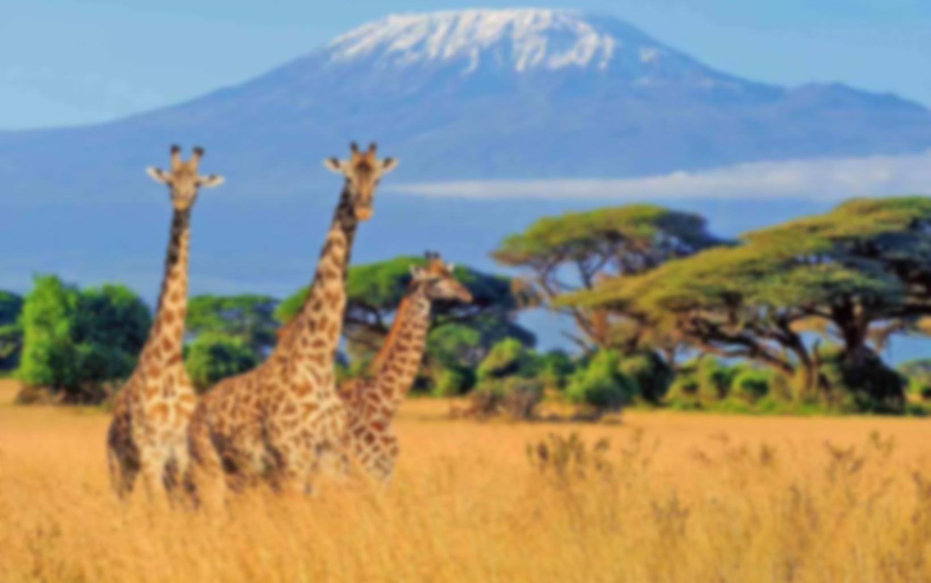
The Big Topic Question:
What can we learn about ourselves by studying other cultures?
How has trading with Africa and learning about different cultures and traditions changed our lives in Long Hanborough? How has it enriched our lives?
- Use all the previous learning points to determine how much our country has benefited from its relationship with Africa. Discuss and clarify any misconceptions.
- Produce an information text to explain your answer to the Big Topic Question.

Learning point 2: Exploration of Africa
I can explain how explorers have helped us to learn more about a different continent
- Share a simplified version of the exploration of David Livingstone and Mary Kingsley.
- Trace their path of exploration on a map and question what it was like to explore a new place for the first time.
- Discuss hardships and make a simple boardgame to summarise the excitement and dangers of exploration.
Why is it important that explorers share their experiences with other people?
Learning point 3: The Suez Canal.
I can explain why the Suez Canal is important to world trade
- Define what a canal is and why the Suez Canal was built.
- Create mini-barges to carry ‘cargo’ from one place to another by travelling on the canal.
- Look at the impact caused when the canal became blocked in 2021.
Why is the Suez Canal so important for world trade routes?
Learning point 1: Trade between Africa and the UK
I can explain the importance of trade between African countries and the UK
- Explain what trading is and identify which goods are traded between both African countries and the UK.
- Simulate the trading of goods and explore how long trade between these countries has been going on.
- Learn how trade first began, and how we can learn from past mistakes.
How has trade with Africa impacted our lives today?

Vocabulary

Exploration: Going to new places to discover and learn about them.
Explorer: A person who travels to new and unknown places to learn about them.
Cultural Exchange: Sharing and learning about each other's customs, traditions, and ways of life. When people from different places trade, they also share a bit of their culture.
Goods: Things that people make or grow, like toys, food, or clothes. During trade, people exchange goods to get what they need or want.

Previous Knowledge
- Understands how past events and actions can affect our world today.
- Understand that some foods are grown in hot countries and others are grown in colder countries.
- Understand how we learn about places and events from primary sources, like diary entries.
Key Concepts
- Trade: exchanging of goods, services, ideas and cultures with others.
- Culture: the arts, ideas, customs, and social behaviour of a particular people or society.

Amazing Africa
Comparing the UK and Africa

