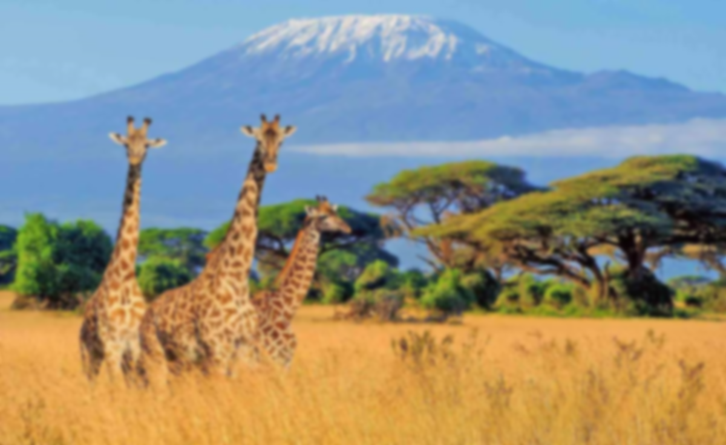
Vocabulary

Diversity: The presence of different cultures, languages, and traditions within a community.
Continent: A large landmass, and Africa is the second largest of the seven continents on Earth.
Tradition: A custom or practice that has been passed down from generation to generation.
Market: A place where people buy and sell goods, often a central part of trade.
Ethnicity: The cultural identity and heritage shared by a group of people.
Heritage: The cultural, historical, or natural aspects that are passed down through generations.
Learning point 5: Folktales and Stories
Explain how stories share and celebrate cultural values.
- Identify a traditional story from the UK (Robin Hood) and one from Africa (Anansi the Spider).
- Discuss the morals and the traditions seen in both stories.
- Children create a simple puppet show and recreate the stories.
- Summarise how cultural values are celebrated in each story.
How do stories help to share cultural ideas and traditions between generations?

Learning point 4: Cultural celebrations in the UK and Africa
Compare the cultural celebrations in the UK and Africa.
- Look at Christmas, Bonfire night, Kwanzaa and Diwali.
- Discuss what the events celebrate and how people celebrate them.
- Create a Venn diagram to identify similarities and differences between all four celebrations.
Why is it important to acknowledge and show respect to other cultures and their traditions?
Learning point 3: Long Hanborough and Franschhoek.
Compare a village in the UK to a village in Africa.
- Locate each village and look at the physical landscape of both.
- Identify the importance of agriculture to both villages.
- Discuss both being community based compared to urban centres.
How are Long Hanborough and Franschhoek similar and different?
Learning point 2: Landscapes and Habitats.
Identify the physical geography of England and Kenya and some key flora and fauna of each.
- Look at the weather patterns and temperature of the UK and Kenya.
- Identify some of the main wildlife of each.
Why are some animals and plants native to Africa and not the UK?
Learning point 1: Continents and Oceans.
I can locate the continents and oceans on planet Earth.
- Use a large map to locate the continents and oceans on planet Earth.
- Locate Long Hanborough and the capital cities of the countries in the UK.
- Locate some countries within Africa, identifying their capital cities
What’s the difference between a country and a continent?

Key Concepts
- Trade: exchanging of goods, services, ideas and cultures with others.
- Culture: the arts, ideas, customs, and social behaviour of a particular people or society.
Previous Knowledge
- Understand the difference between a village and a city.
- Know that London is the capital of England.
- Know the UK is made up of 4 countries.
- Understand weather patterns of the seasons in the UK.
Amazing Africa
Comparing the UK and Africa

