Later learning:
- Year 3/4: Animals including humans.
- Year 5/6: Evolution and inheritance, living things and their habitats, Animals including humans.
Year 1/2 Science KCV
Humans
Key concept vocabulary:
- Offspring
- Grow
- Adults
- Water
- Food
- Air
- Exercise
- Hygiene
- Nutrition
- Reproduce
- Baby
- Toddler
- Child
- Teenager
- Adult
Prior knowledge / understanding:
- PSHE discussions about growing and changing.
- EYFS discussions around babies/younger siblings etc.

Key knowledge and outcomes: Children will be able to…
- Say the three things that humans need to stay alive.
- Give examples of healthy and less healthy food.
- Name some things that humans do to keep themselves clean.
- Use a magnifying glass or microscope to look closely at their hands.

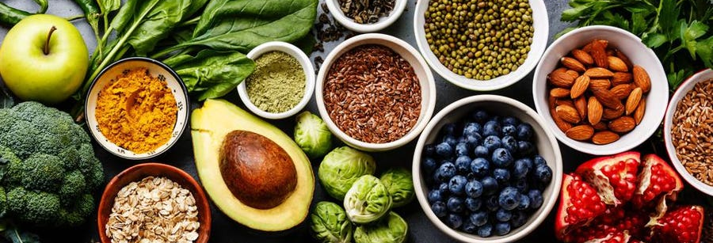

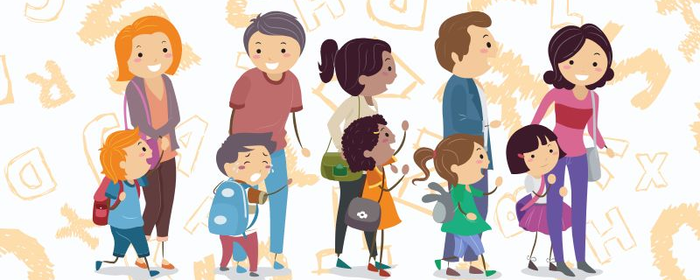
Key assessment questions:
- Can you describe the changes that happen to a human when they grow up?
- Draw a plate with a healthy meal on it.
- What form of exercise if your favourite? Why?

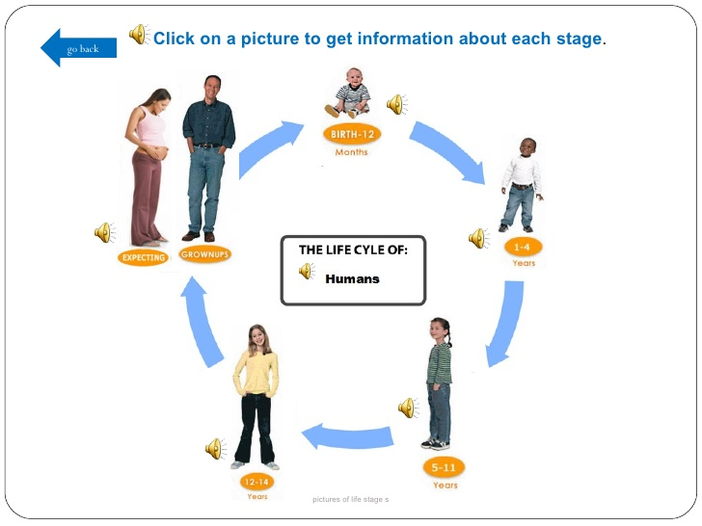
Useful links/resources:
- https://www.stem.org.uk/resources/community/collection/12727/year-2-animals-including-humans
- https://www.hamilton-trust.org.uk/science/year-2-science/animals-including-humans-healthy-animals/
- https://www.twinkl.co.uk/resource/tp-sc-105-planit-science-year-2-animals-including-humans-unit-pack
Books:



