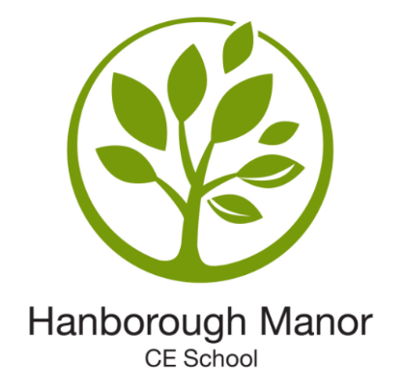

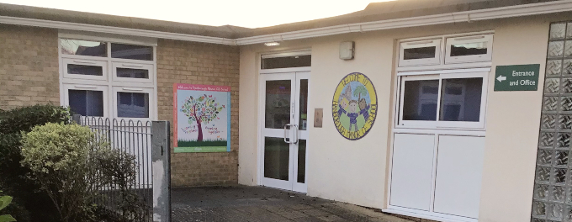
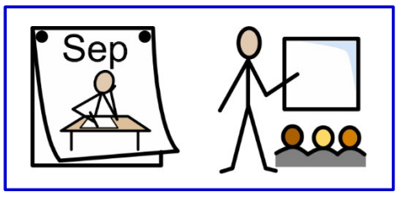
2025

I’m going into Foundation.
My class is called
Holly Class.



I am getting bigger and older.

In September, I will be going to school where I will be going into Holly Class.

I will be moving to school with the some of the children I have been with at Pre-School and I have met some new friends during my visits to Holly Class already.

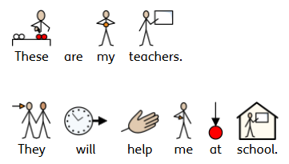

Mrs Rose
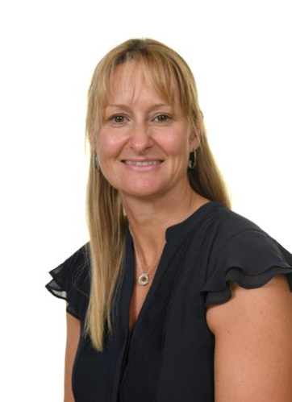
Miss Auton
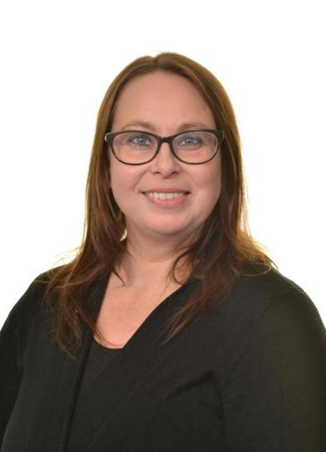


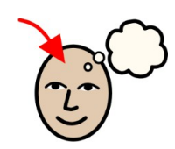
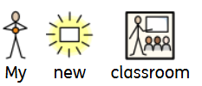
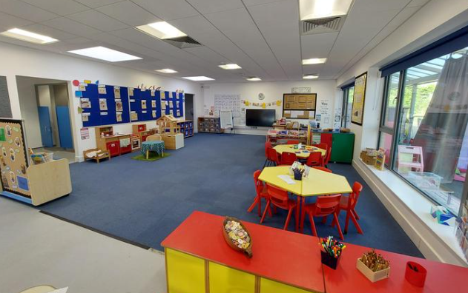
These are the toilets I will use.
This is where I will learn while I am in Foundation.

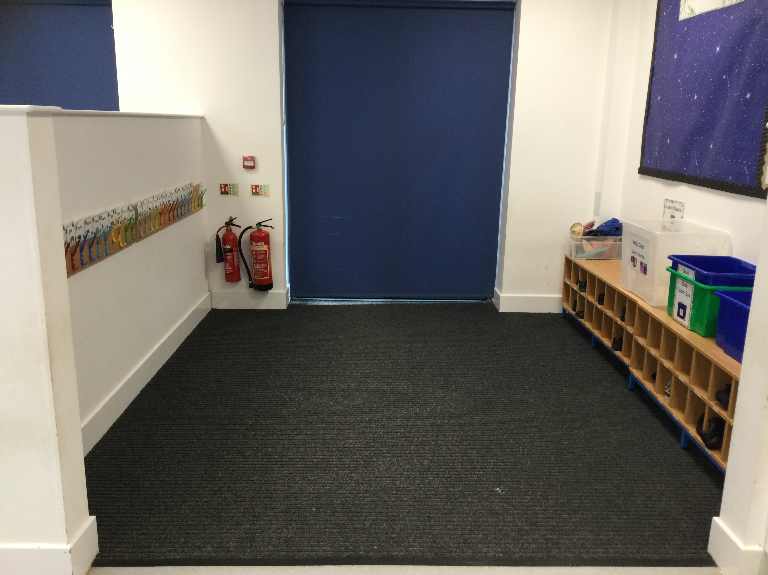

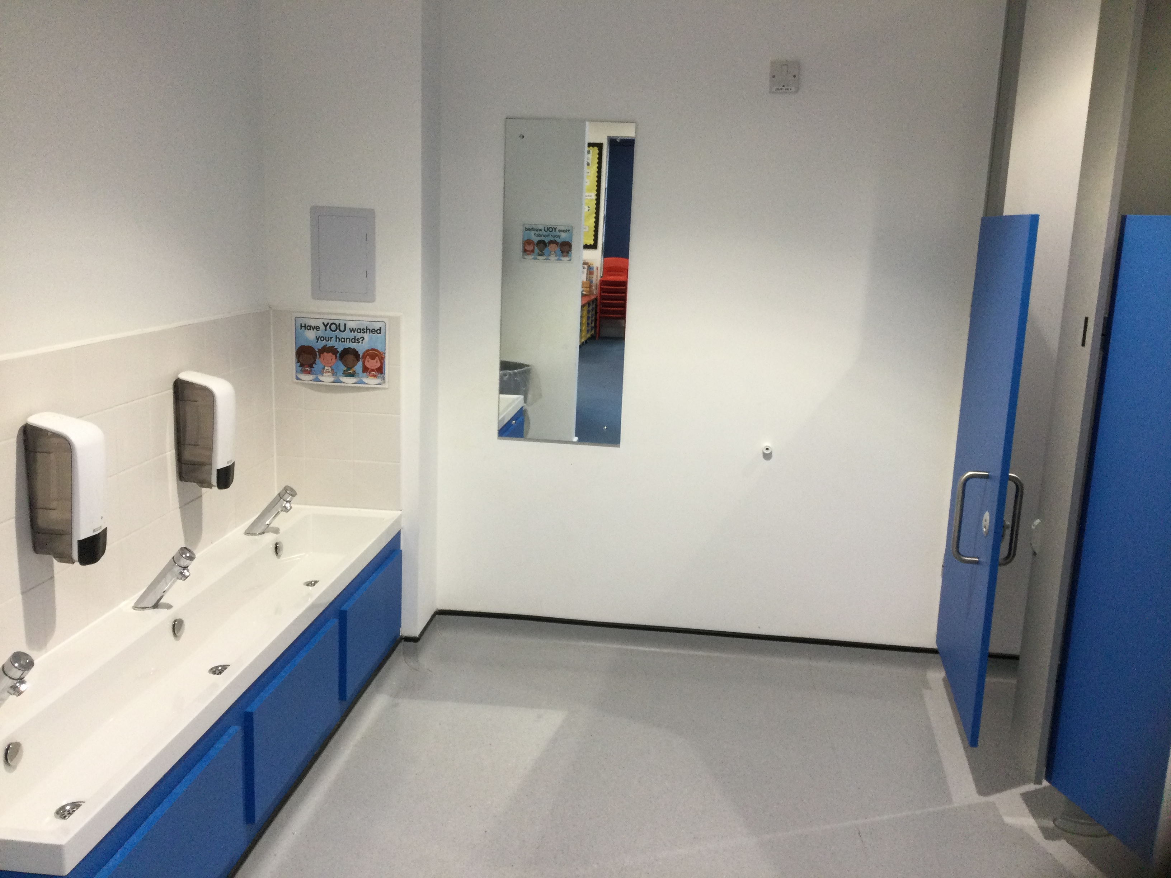
This is the cloakroom where I will put my coat and belongings.
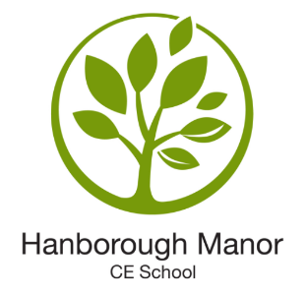

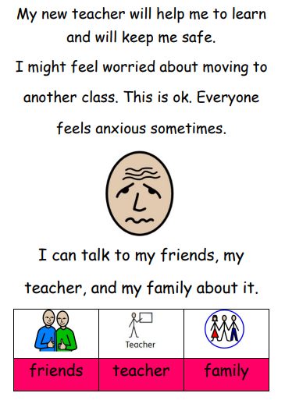
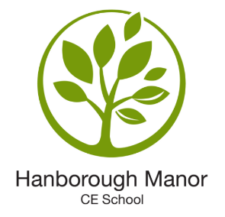

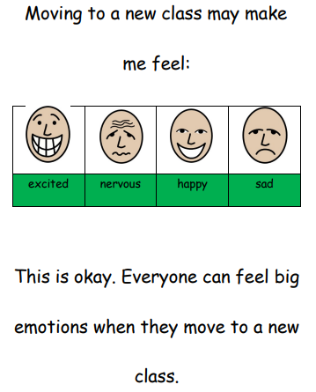
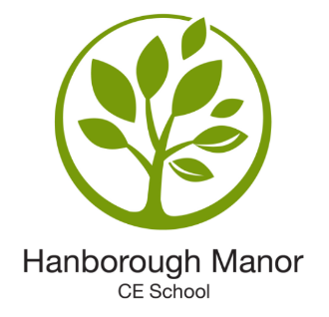

My Teachers are really looking forward to seeing me in September after the summer holidays.
I can show them my ‘All About Me Book’ and tell them about my favourite things, who is important me and what I like to do.
I can keep my ‘All About Me Book’ in my new Class so I can show my new friends too.

