

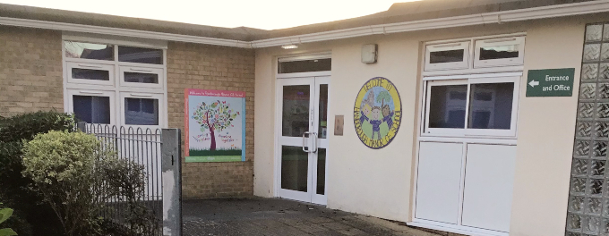
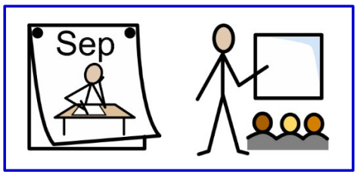
2025

My name is _______ and I’m going into year 1.

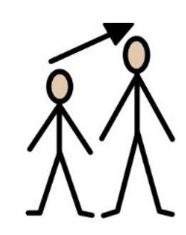

I am getting bigger and older.

In September, I will moving up and will be going into year 1.

I will be moving to Year 1 with the same children I have been with in Foundation Stage. There are 30 of us.

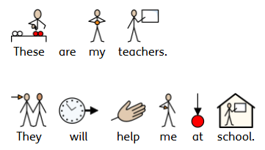

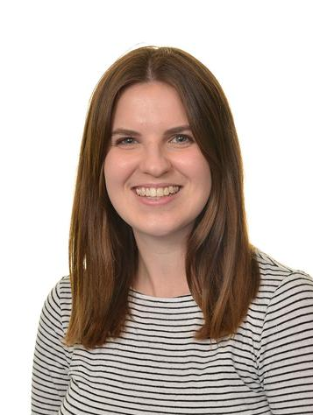
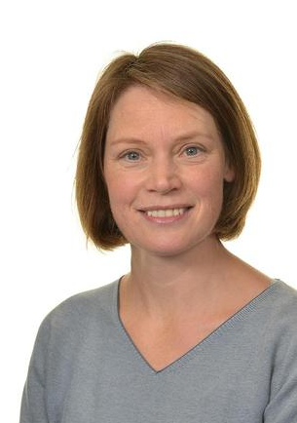

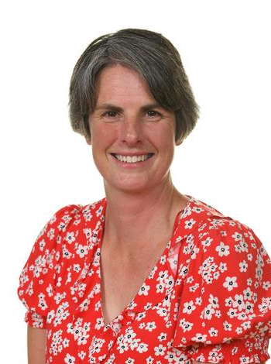
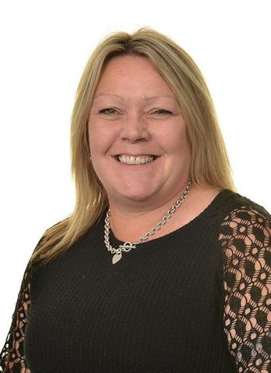
Miss Simpkins
Miss Tompkin
Miss Jones
Mrs Fox

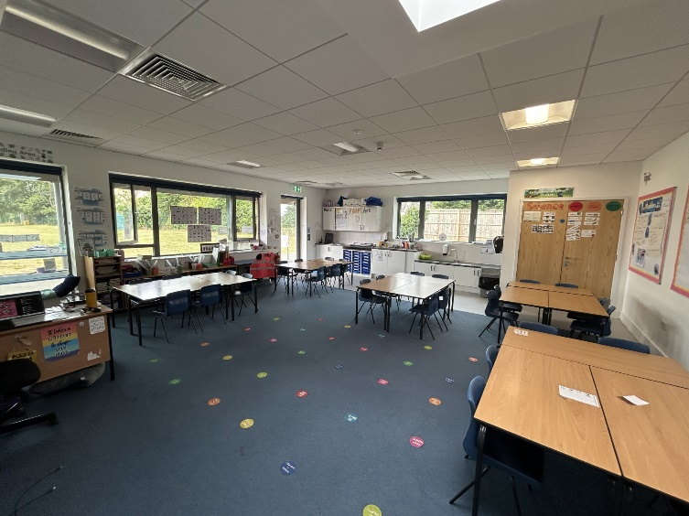


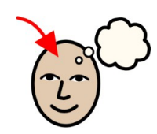
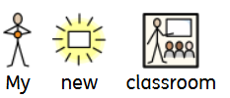
These are the toilets I will use.
This is the cloakroom where I will put my coat and belongings.
This is where I will learn while I am in year 1.
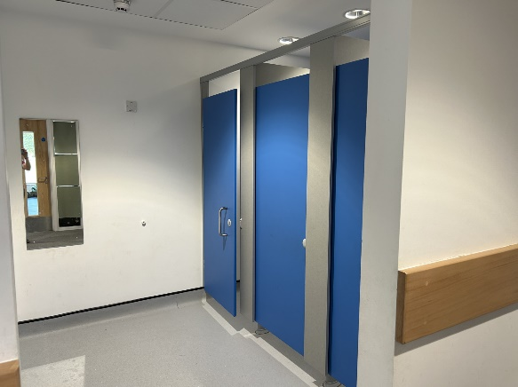
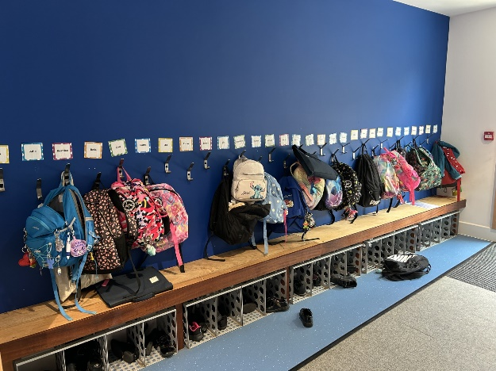


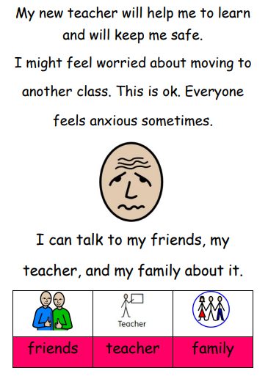


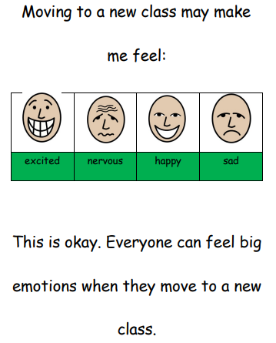


It can also be helpful to find out and have some facts about your next class so that you feel a bit more confident or less worried about what will happen.
See if you can complete the following challenges in this workbook.

CHALLENGE WHAT DO YOU WANT TO KNOW?

Can you think of some questions to ask about your class next year?
- …
- …
- …

In your next class some things will be the same and some things will be different

CHALLENGE: SAME OR DIFFERENT?
Discuss and write down 3 important things that will probably be different in your next class.
WORD CLUES TO HELP YOU THINK OF IDEAS:
lunchtimes, playtimes, teachers, friends, lessons, homework, desks, storage uniform, rooms, timetable, rules, assemblies,
1.
2.
3.

