My Moving Class Transition Book

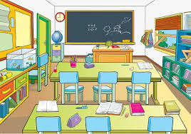

Name……………………………………………………

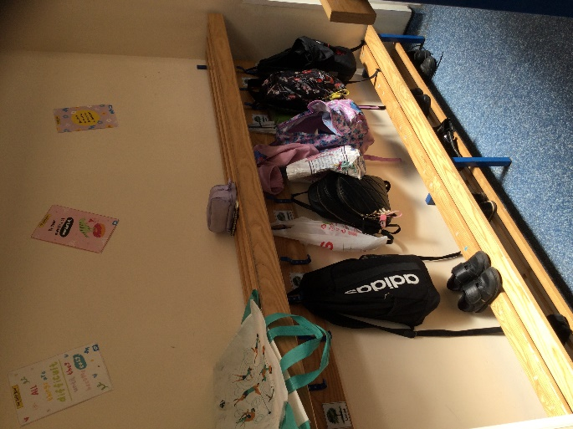
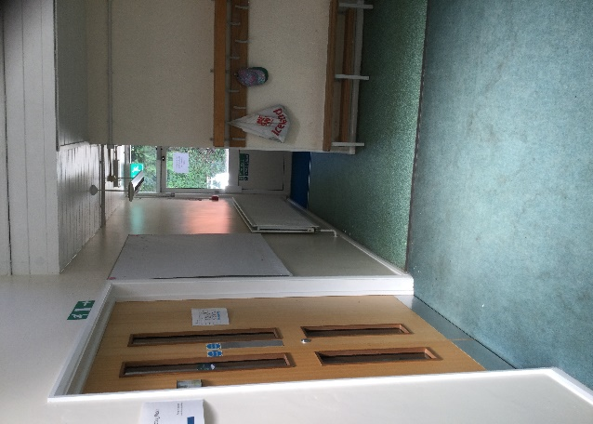
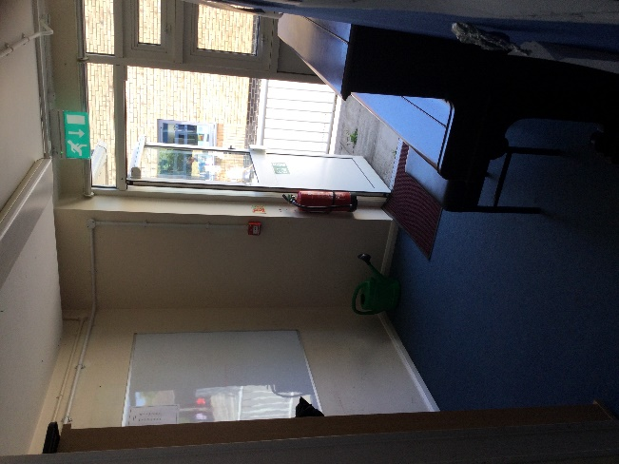
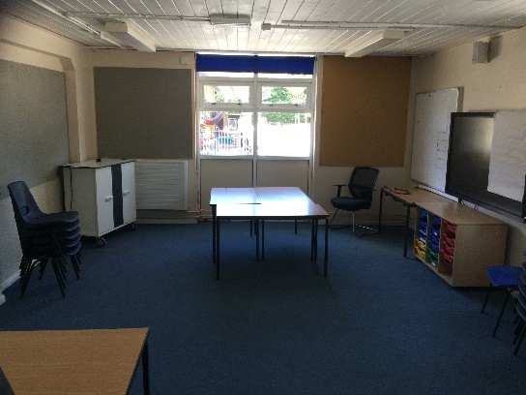
In September I will be moving to my next class! It is the old art room so it will be a room you’ve all been in before. Also, the art room will be getting a face lift over the Summer holidays and so it will look fresh and rearranged ready to be your wonderful classroom for Year 3!
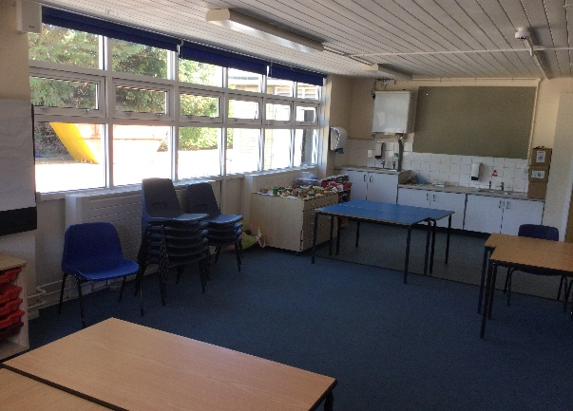

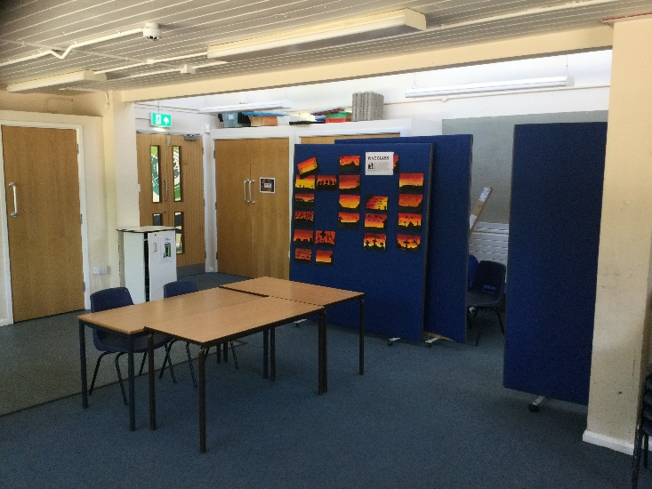


I will be in Year 3 in Sycamore Class.

My next teacher is called Mr. Hagon

Mr. Hagon likes music, hiking and reading!

The teaching assistant who will sometimes be helping me in my next class is

Miss Edwards.

Miss Edwards likes reading (on her
new kindle), swimming and spending
time with her family.

I will be moving to Year 3 with the same children I have been with in Year 2. There are 29 of us.

I might feel a bit sad to leave my teachers Mrs. Jones and Mrs. Baker-Roberts, but I will be moving up with Miss Edwards!
This is OK. I could make them a special card to say thank you and goodbye.

Some people feel a little bit worried about starting in a different class. This is OK too. If you feel sad or worried you should tell an adult or friend who you know well and they will help to reassure you.

It can also be helpful to find out and have some facts about your next class so that you feel a bit more confident or less worried about what will happen.

See if you can complete the following challenges in this workbook.

CHALLENGE WHAT DO YOU WANT TO KNOW?
Can you think of some questions to ask about your class next year?
- …

- …

- …

- …

- …

In your next class some things will be the same and some things will be different

CHALLENGE: SAME OR DIFFERENT?
Discuss and write down 3 important things that will probably be different in your next class.
Draw a picture of your next teacher.

WORD CLUES TO HELP YOU THINK OF IDEAS:
lunchtimes, playtimes, teachers, friends, lessons, homework, desks, storage, uniform, rooms, timetable, rules, assemblies.

1

2

3

CHALLENGE WHERE AND WHEN?

Write the answers and/or tick the boxes when you know the answers to these questions about your next class:

I will start in my next class on Tuesday 2nd September

Which door should you go into school through?

You will come through the door by the outside PE cupboard when Mr. Hagon comes to greet you.

Where should you put your coat and bags?

You will put your things in the Year 3 cloakroom. Your peg will have your name label.
What time will break time usually be?

Breaktime will be at 10:40, just like normal.
What time will lunch time usually be?

Lunchtime will be at 12:00, just like normal.
What time will home time usually be ?

Home time will be at 3:10, just like normal.

Find out if and when you will do any other
activities, such as residentials, swimming or forest school
and list them in the box below:

Activity | When

