My Moving Class Transition Book

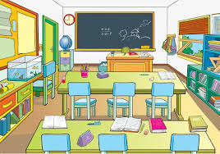

Name……………………………………………………

In September I will be moving to my next class!

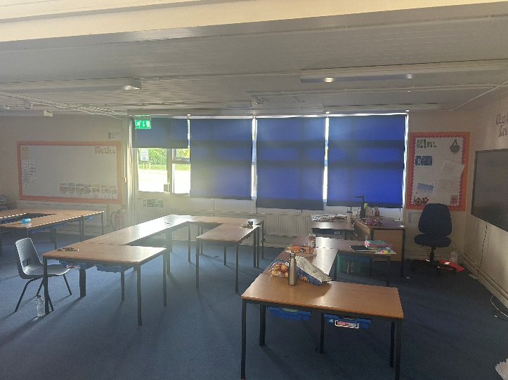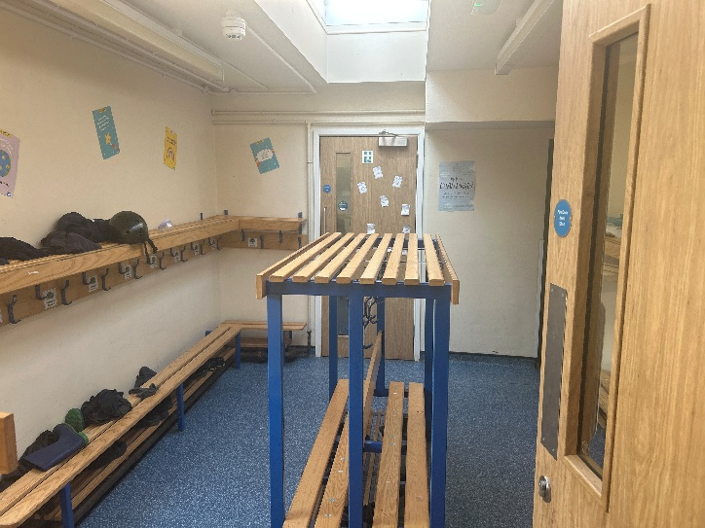


I will be in Year 4 in Elm Class.

My next teacher is called Miss Potter.

Miss Potter likes singing, sports and reading!

The teaching assistant who will sometimes be helping me in my next class is
Mrs Miller.


Mrs Miller likes walking, singing and listening
to music!

I will be moving to Year 4 with the same children I have been with in Year 3. There are 29 of us.

I might feel a bit sad to leave my teachers Mr Hagon and Miss Simpkins.
This is OK. I could make them a special card to say thank you and goodbye.

Some people feel a little bit worried about starting in a different class. This is OK too. If you feel sad or worried you should tell an adult or friend who you know well and they will help to reassure you.

It can also be helpful to find out and have some facts about your next class so that you feel a bit more confident or less worried about what will happen.

See if you can complete the following challenges in this workbook.

CHALLENGE WHAT DO YOU WANT TO KNOW?
Can you think of some questions to ask about your class next year?
- …
- …
- …
- …
- …

In your next class some things will be the same and some things will be different

CHALLENGE: SAME OR DIFFERENT?
Discuss and write down 3 important things that will probably be different in your next class.
Draw a picture of your next teacher.

WORD CLUES TO HELP YOU THINK OF IDEAS:
lunchtimes, playtimes, teachers, friends, lessons, homework, desks, storage uniform, rooms timetable, rules, assemblies,

1

2

3

CHALLENGE WHERE AND WHEN?

Write the answers and/or tick the boxes when you know the answers to these questions about your next class:

I will start in my next class on Tuesday 2nd September

Which door should you go into school through?

You will come through the Year 4 cloakroom door when Miss Potter comes to greet you.

Where should you put your coat and bags?

You will put your things in the Year 4 cloakroom. Your peg will have your name label.
What time will break time usually be?

Breaktime will be at 10:40, just like normal.
What time will lunch time usually be?

Lunchtime will be at 12:00, just like normal.
What time will home time usually be ?

Home time will be at 3:10, just like normal.

Find out if and when you will do any other
activities, such as residentials, swimming or forest school
and list them in the box below:

Activity | When

