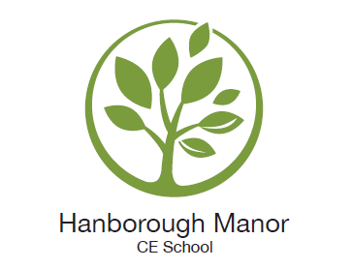

NOTIFICATION OF INTENT TO REMOVE A CHILD DURING TERM TIME

Please complete the slip below and return to the Headteacher at least fourteen days before the proposed absence. You will receive a letter informing you of the decision.

Changes to the Education Regulations:
Recent amendments to the registration regulations have removed references to family holidays and extended leave as well as the threshold of ten school days at the discretion of the Head. From 1 September 2013, Headteachers may not grant any leave of absence during term time unless there are exceptional circumstances*.

Failure to request permission for leave, or refusal to grant leave, will mean that the absence is unauthorised. Schools are required to notify the DfE and the LA of all unauthorised absences. No leave can be granted during the SATs period.

Please indicate below why you are removing your child(ren) from school during term time and confirm that you aware that any absence will be recorded as unauthorised, other than in exceptional circumstances*.
__________________________________________________________________________________________
To: The Headteacher, Hanborough Manor CE School

Child(ren) name(s): ……………………………………………………………...…………..Year(s):……………………

It is my intention to remove my child(ren) from school during term time

from ……………………………….…... to ………………..…..….……………(dates). Total no. school days…………

Please give a full account as to why you are removing your child from school:

Please use the reverse of this sheet if needed

I understand that the school will not provide work for my child whilst absent from school or provide a catch-up programme.
Signed…………………………………………...………………………………..…Date………………………

For office use only:
□ Authorised □Unauthorised

Signed: ……………………………………………………………………..Date:…………………………………………………………

*Examples of exceptional circumstances: a close relative is ill; there has been a significant trauma in the family; a never to be repeated experience, which can ONLY take place at the time requested (ie is a rare event in a child’s life – this does not include holidays).

