Collective Worship Policy
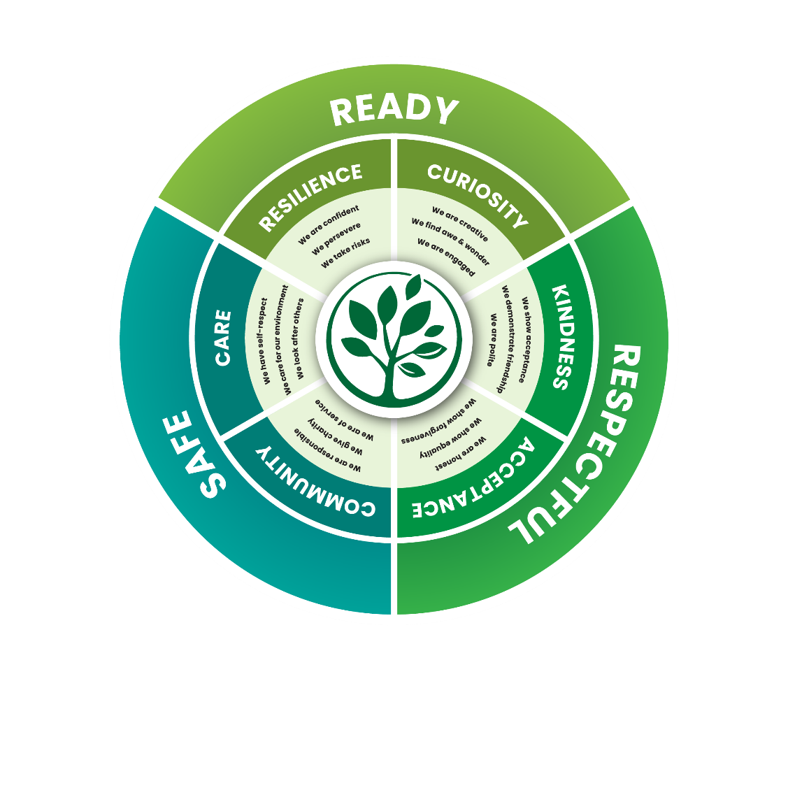
Date policy approved and adopted: 16.07.2026
Signed on behalf of the Governors: Chris Jones
Signed by Headteacher: Sarah Nickelson
Date for review: July 2029
Our school vision
Aim High, be Courageous, show Love and Kindness.
Our strong Christian vision is underpinned by these words from the Bible:
"Keep alert, stand firm in your faith, be courageous, be strong. Let all that you do be done in love"
(1 Cor 16:13 - 14)

Aim high, 'Keep alert' - look for opportunities to improve, progress and learn new things.
Be courageous, 'stand firm in your faith, be courageous, be strong'- be brave enough to try new things, make mistakes and succeed; to stand up for what you believe is right and make a difference.
Show love and kindness, 'let all that you do be done in love'-treat everyone with love and kindness at all times; value yourself as a unique creation.

Our vision is that every child and member of our school community is welcomed and valued as a unique individual, supported and empowered to flourish by our caring, inclusive and engaging ethos and curriculum.
Our vision is exemplified by the parable of the Good Samaritan (Luke 10: 25 - 37), allowing children to connect and understand our vision more fully.
Our vision is reflected in our nominated six values (resilience, curiosity, kindness, acceptance, community and care) and our rules for expectations of everyone's behaviour:
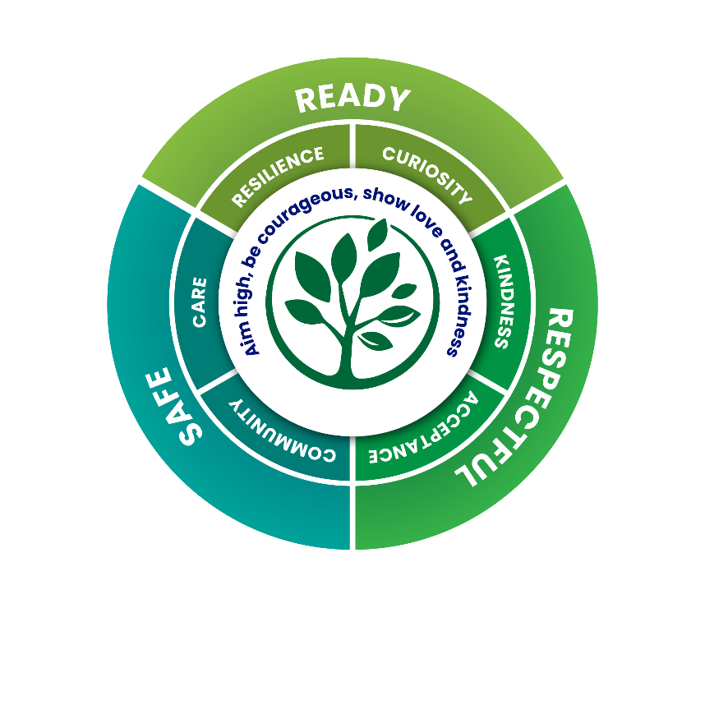

At Hanborough Manor School, Collective Worship is central to the life of our school community. It is an opportunity to promote the Christian foundation of our school, to celebrate and give thanks to God for all aspects of school life and to provide time for stillness and reflection in what is often a very busy, active day for our children. It is attended by pupils and staff; we warmly invite any visitors in school to join us. Our Collective Worship is intended to be appropriate for, and to include, all pupils attending Hanborough Manor School, regardless of their own personal faith.

How is a Church of England school different?
“A Christian school is one in which the atmosphere has that kind of openness about it, that sense that people are worth spending time with, that people need time to grow, need loving attention. … It doesn’t necessarily mean that everyone involved has to share the same theology or philosophy … but a Christian school is one in which the entire atmosphere is pervaded by the conviction that there is something mysterious, and potentially wonderful, in everybody.” Rt. Rev. Dr. Rowan Williams

Collective Worship in school differs from the corporate worship of believers of a particular faith. We recognise that in our school we have children from a variety of faith traditions, including those who have no faith background at all. Great care and sensitivity is taken to ensure that all our children feel valued and special, collective worship aims to be inclusive, invitational and inspiring.

While the law requires a daily act of collective worship that is broadly Christian in nature, we ensure that worship at Hanborough Manor School is clearly rooted in the teachings and values of the Christian faith, in accordance with the principles and practice of the Church of England. At the same time, we are committed to ensuring that collective worship is inclusive and invitational, enabling all pupils to engage in a way that is appropriate to their own beliefs and backgrounds. Collective worship will encourage reflection, respect and understanding of other faiths and worldviews, while maintaining the integrity of our Christian foundation and avoiding any sense of compulsion.

Aims
The aims of worship at Hanborough Manor School are:

to create an atmosphere in which genuine worship may take place and where pupils’ own beliefs are valued and each one has the opportunity to respond in their own way;

to enable pupils to reflect on the school values (Christian in nature) and to explore their own beliefs;

to explore and enable pupils to understand our school vision;

to bring staff and pupils together to experience the security of belonging to a community with an identity of its own;

to explore Christianity from a multi-cultural, global perspective, fostering a respect for peoples of all ethnic origins;

to make an important contribution to the spiritual, moral, social and cultural development of pupils;
celebrate and give thanks to God for achievements within the school, local and international community and occasions of significance, including festivals;

to support the broader creative curriculum through the use of art, music, dance, poetry, story, drama and other visual and oral means of communication.

Worship will reflect aspects of the curriculum and in particular will:
nurture spiritual growth;
enable participants to consider moral questions in a Christian context;
enhance social understanding and encourage responses to issues through courageous advocacy;
give participants a chance to reflect on the place and importance of faith in the lives of people today;
encourage participants to explore beliefs drawn from their own cultural heritage;
reflect the teachings of Jesus and a trinitarian theology

The Legal Requirements and attendance
The 1988 Education Reform Act states that Collective Worship must be on a daily basis for all registered pupils. The religious foundation of Hanborough Manor School as stated in the Trust Deed is Church of England and the daily act of Collective Worship is delivered in accordance with the principles and practice of the Church of England.

Parents may ask for their child(ren) to be totally or partially withdrawn from Collective Worship in accordance with the Education Act. They are advised of this right in the school’s prospectus and asked to contact the Headteacher to make arrangements. No reasons have to be given and no discussion with parents over the issues concerning withdrawal will be necessary. Staff also have the right to withdraw. However, to give pupils the message that this is an important time of the school day, adults are encouraged to be present.

Staff and children (unless they have been withdrawn) should all attend at least Monday’s collective worship so that they have a full understanding of the theme of the week and support children through discussion in class. All children should attend collective worship unless there is an exception and if they need to be absent that this is not a regular occurrence.

Responsibility
The responsibility for arranging and coordinating Collective Worship in our School rests with the Headteacher.
The School recognises that there is a difference between Acts of Collective Worship and the assembly of pupils. On some occasions Assembly may precede or follow an Act of Collective Worship. When this happens the transition from Assembly to Worship will be marked in some suitable way e.g. the lighting of a candle or reflecting on a displayed image, moment of silences and reflection etc.
Worship framework
Worship themes are planned termly (see appendix one) and reflect the School’s ethos.
Although the themes will be revisited on a three-yearly basis, they are broad enough to allow for sufficient choice and flexibility.
Planning
Each week there is a bible theme linked to the value of the term. This is used to plan the collective worship and includes a song and music linked to the theme.

Organisation
Each term’s Collective Worship is assigned a theme (see Appendix one) and wherever possible, Collective Worship should also be linked to one of the School’s core values and vision. The values wheel can be used as a point of reference.

Our usual collective worship timetable is:

Organisation
Our usual collective worship timetable is:

Day and time | Year groups | Taken by | Theme
Monday 10.20am | Whole school | SLT | Termly CW theme
Tuesday 10.20am | Whole school | Local clergy | Termly CW theme
Wednesday 10.20am | Whole school | Music lead | Singing
Thursday 10.20am | Whole school in classes | Class teachers | Jigsaw theme
Friday 10.20am | Whole school | SLT | Celebration and safety

Opportunities for contemplative worship are provided through the use of the Spacemakers resources. This introduces the five habits of stilling, noticing, dwelling, mending and blessing within the context of a class worship session. This may take place outside the morning worship.

In order to promote our pupils’ learning and meet the needs of different age groups, our Collective Worship times vary in size and groupings. (See appendix two.)

At significant times in the Christian/school calendar (such as Harvest, Christmas, Easter, the end of the school year), services take place for the whole school community in St Peter and St Paul’s Church. Parents, friends and Governors are also invited to attend.

Our Approach
Leaders of Collective Worship
Leaders of Collective Worship are encouraged to be creative and engaging in the ways they communicate the message. Acts of Collective Worship are generally led by members of staff with pupils involvement being encouraged. Once a week, a representative from one of our local Churches leads Collective Worship for the whole school. On occasions outside speakers are invited to take part in Collective Worship, for example charity workers.

Location of Collective Worship
Worship takes place as a whole school in the hall and sometimes outdoors. At other times worship can be in individual classes in classrooms.

Format of Collective Worship
Collective Worship should last for approximately 15 minutes.

Acts of Collective Worship follow an agreed format:

Entrance: Children come into the hall to thought provoking and awe inspiring images on the screen and music playing.
Welcome: Collect linked to the term’s value and lighting of the candle by the Liturgy Team (see below for more information)
Value: The value is explored with strong links to the Bible and Christian teaching. Links could be made to current/world affairs. Real life stories and experiences may be used along with other stimuli that promote deeper thinking about the value.
Opportunities will be given for pupils to broaden their understanding of Christianity as a multi-cultural world faith.
Reflection: As we close the worship, we make a tie into the daily life of the school and how the implications of worship are worked out in our lives. We give the children time to reflect giving them questions or quotes to think about.
Conclusion: We conclude our act of Collective Worship with an invitational prayer followed by a song or hymn (where possible related to content of the worship).

Opportunity for reflective action and follow up
Structured follow-up activities will be embedded in classrooms and school life to deepen pupils’ engagement with worship themes. These may include class discussions, creative projects, acts of service, and community involvement, encouraging pupils to translate reflection into concrete action.

Diversity and multi faith awareness
Collective worship will respect other world faiths and beliefs, fostering mutual understanding and cultural awareness. This will be balanced with the school’s Christian foundation, ensuring pupils appreciate Christianity’s global and multicultural nature.

Links to curriculum and wider school life
Collective Worship themes and values will be explicitly linked with curriculum topics and wider school initiatives (e.g., PSHCE, restorative practices, safety), ensuring coherence and reinforcing learning across contexts.

Accessibility and Differentiation for SEND Pupils
Leaders of collective worship will collaborate with our SENCO to tailor worship content and delivery to meet the specific needs of pupils with SEND, ensuring full participation and engagement. Resources and approaches will be adapted as necessary, including visual aids, sensory activities, and simplified language.

The Liturgy Team
The Liturgy Team are made up of a group of children from Year 5 who have the following responsibilities:
- Setting up the assembly hall (setting up of altar, arranging chairs etc.)
- Open collective worship by reading our vision summary (Aim high, be courageous, show love and kindness) every time we gather as a helpful reminder to the school. At the end of this the team will introduce the value we are focusing on and welcome the leader of the worship
- Light the candle
- Contribute and lead parts of Collective Worship
- Support visitors
- Finish with our school prayer as a united, affirming hope and prayer going into the day
- Once termly - monitoring Collective Worship in School
The staff also seeks to take advantage of spontaneous opportunities to develop
children’s spirituality that arise throughout the school day.

Professional Development
Regular professional development opportunities will be provided for all staff involved in leading collective worship to ensure worship is delivered effectively, sensitively, and in accordance with current legal and educational guidance. Training will include understanding of diverse faiths, inclusive practice, and fostering critical reflection.

Evaluation and Monitoring
Children evaluate worship through discussions with staff and our worship team, which serve to reinforce the themes. Feedback is given through regular pupil voice, parents, staff, Governor and visitor feedback, photographs and reflections. Evidence is collated in a book kept in the school hall.
The Headteacher alongside our spirituality lead has overall responsibility for monitoring worship; Governors are also involved in the monitoring process.

The school will review this policy every three years. The policy will be promoted and implemented throughout the School.

HANBOROUGH MANOR SCHOOL

Values for 2025-2026
Term | Value
1 September- October | Friendship
2 November- December | Peace
3 January- February | Creativity
4 February- April | Trust
5 April-May | Forgiveness
6 June-July | Justice

Values for 2026-2027
Term | Value
1 September- October | Courage
2 November- December | Compassion
3 January- February | Thankfulness
4 February- April | Humility
5 April-May | Truthfulness
6 June-July | Hope
Values for 2027-2028
Term | Value
1 September- October | Respect
2 November- December | Resilience
3 January- February | Curiosity
4 February- April | Community
5 April-May | Service
6 June-July | Care

