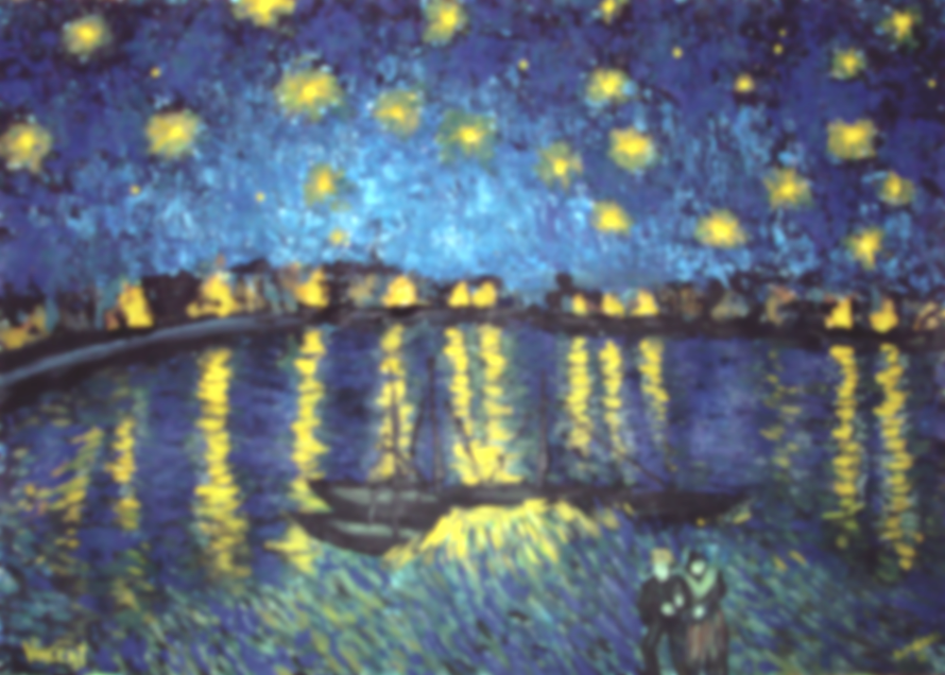
Vocabulary

Primary Colours: red, blue and yellow.
Secondary Colours: green, purple and orange.
Tint: adding white to a colour.
Shade: adding black to a colour.
Sketch: a rough, unfinished drawing or painting.
Critique: analysing in detail

Learning point 1: Artist research
I can find out about a famous artist.
- Look closely at some of the works of Van Gogh.
- Discuss his life and what inspired him to start painting.
- Discuss how his paintings make you feel.
- Record some of this information in a sketchbook.
What are some of Van Gogh’s best-known works.
Previous Knowledge
- Mark making on 2D surfaces.
- The use of line and shape to make recognisable pictures.
- Cleaning brushes between different colours of paint.
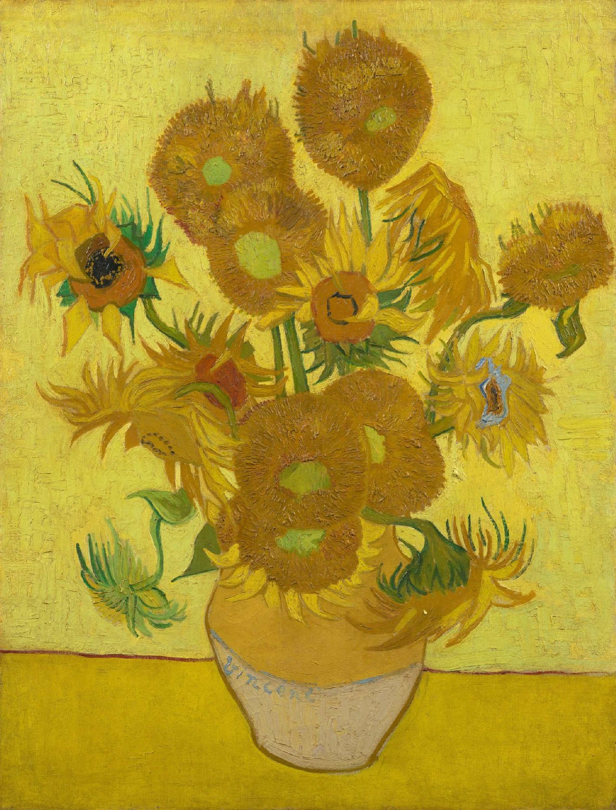
Learning point 3: brush strokes and mark making
I can vary my mark making using different brushes.
- Use thick brushes for blocks of colour and thin brushes for adding detail.
- Look at ‘Sunflowers’ and discuss using light marks to show how to arrange the painting on your page.
Arrange a simple still life and recreate, using a variety of brush strokes and poster paint.
Final Piece: The Great fire of London in the style of ‘The Starry Night’.
I can create a painting in the style of Vincent Van Gogh
- Revise discussion of ‘The Starry Night’ – colour, brushstrokes, shapes, etc.
- Identify the village and church in the painting and compare to the view of London that the children will be painting.
- Model thick and thin brush strokes for washes and detail.
- Paint a scene from The Great Fire of London in the style of Van Gogh.
- Critique your work. How is it similar/different to Van Gogh’s? Do you like this style? Why?
Learning point 4: making informed choices
I can select appropriate brushes and colours to create a painting.
- Look at The Starry Night and discuss it – brush strokes, colours, what you can see, etc.
- Explain that children will be painting a version of this based on the Great Fire of London.
- Plan the colours, brushes, etc, by sketching in books, mixing colours which can be used, and preparing for the final piece.
Plan your final painting, draw a scene from 17th century London, organise brushes and colours.
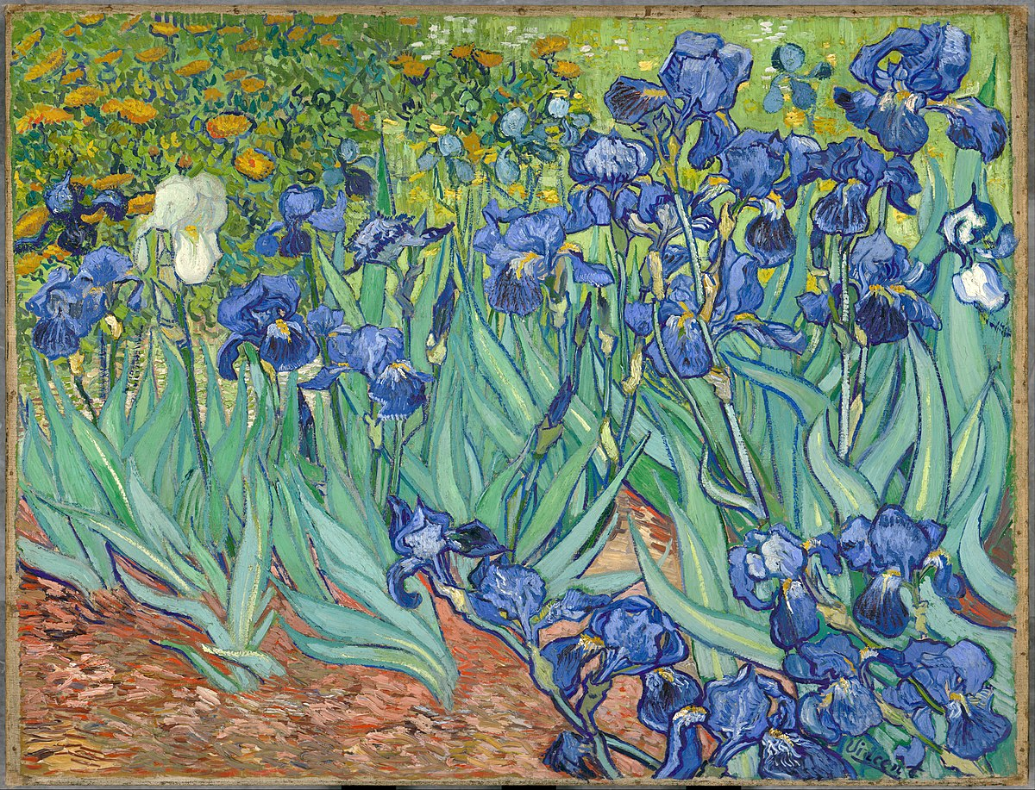
Learning point 2: The colour wheel
I can explain what primary and secondary colours are.
- Introduce the colour wheel and identify the primary colours.
- Mix the primary colours in turn to make secondary colours.
- Discuss making shades by adding black and tints by adding white.
Look at ‘Irises’ and mix secondary colours to recreate the painting in sketch books using poster paint.

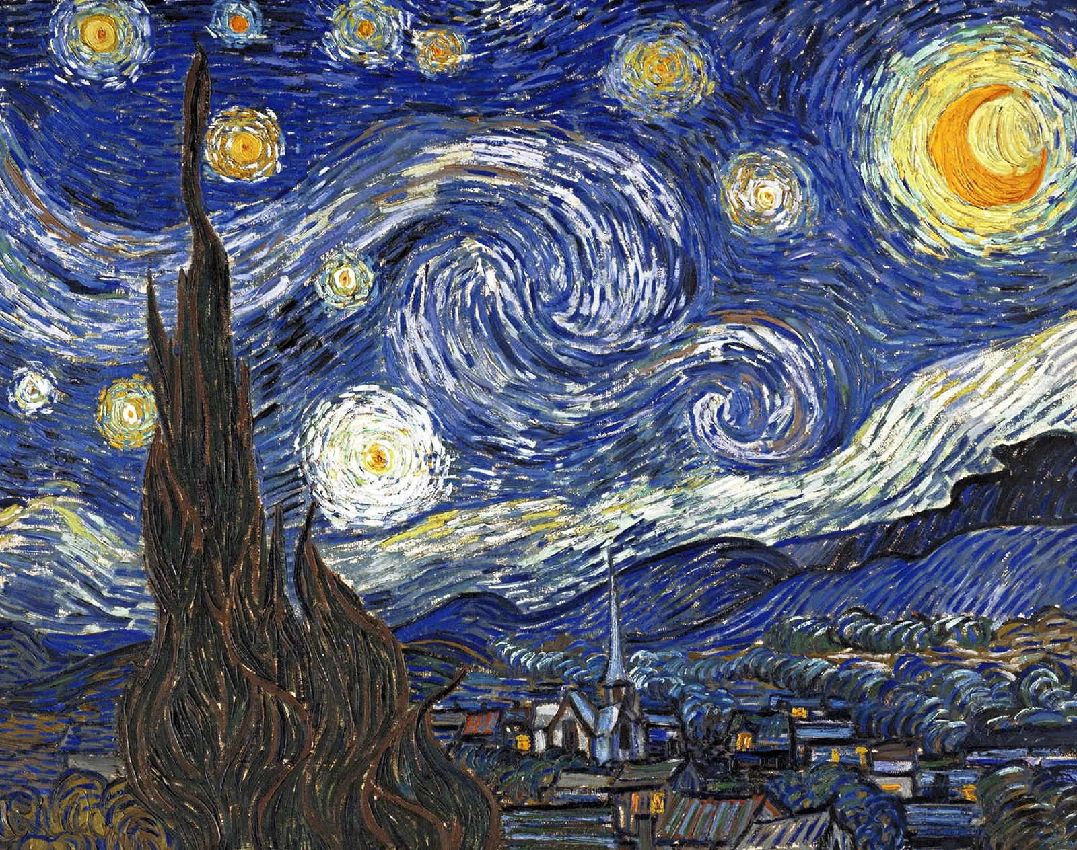
Vincent Van Gogh
The Starry Night

