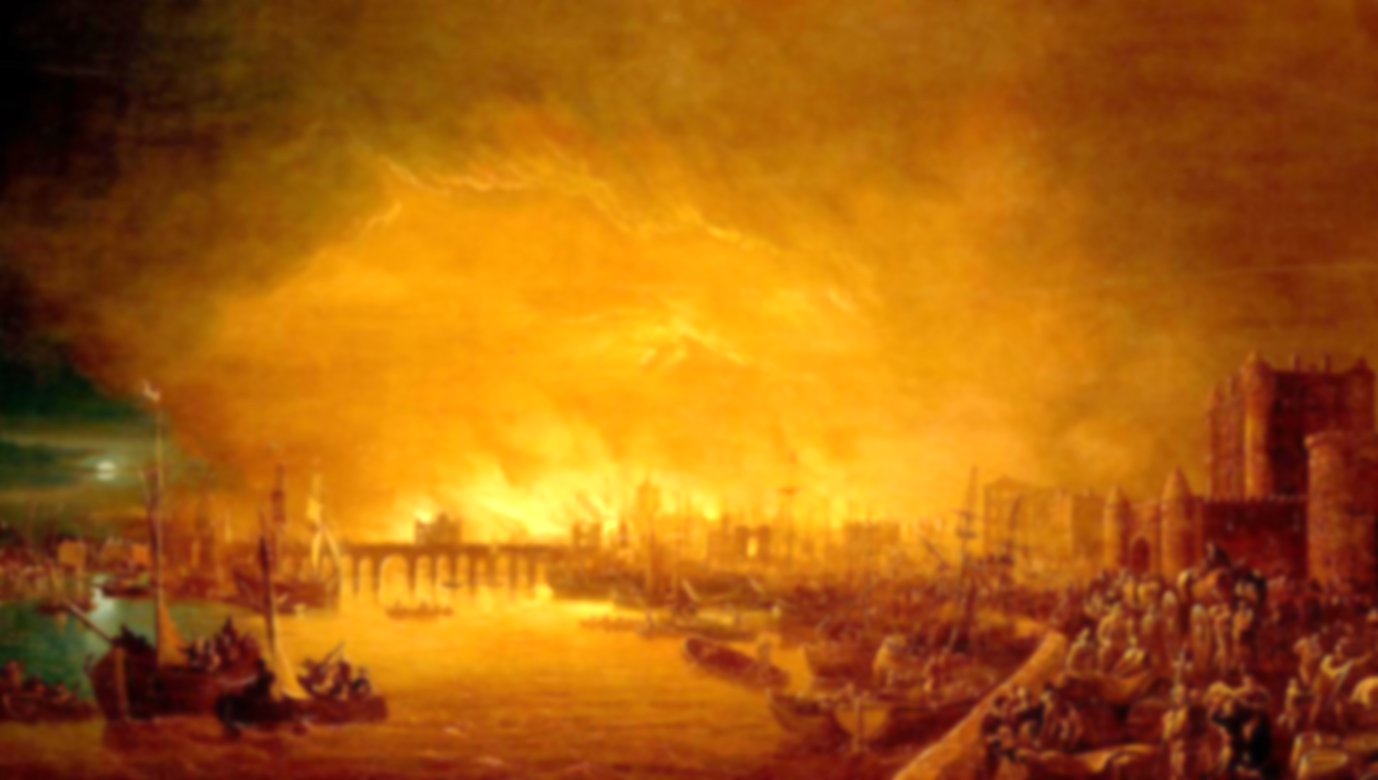
Learning point 3: Did seasonal weather contribute to the fire?
To understand typical weather patterns of the four seasons
- Idenitfy typical weather patterns for each season.
- Understand how the wind can contribute to the spread of fire.
- Discuss how other factors, including physical geography, could help the spread of fire.
Would the fire have spread if it was Winter?
Learning point 2: Hanborough vs. London.
To know and understand the differences between a village and city
- Look at London and Hanborough on maps, aerial photographs and Google Earth.
- Identify physical features including rivers, mounds, forests, etc. Identify human features including shops and train stations.
- Find out population of both London and Hanborough.
- Define hamlet, village, town and city and identify which London and Hanborough are.
What similarities do London and Hanborough have?
Learning point 1: London – then and now.
I can identify how London has changed over time
- Explain that there are four countries that make up the British Isles. Identify the capital cities of each.
- Focus on London being the capital of England.
- Compare London in 1666 to today using pictures and aerial photographs. Notice what has changed.
How has London changed over the centuries?

Vocabulary
Country: a nation with its own government
Capital: the city where the government is based
City: a large town
Village: a group of houses in a rural area
Rural: the countryside
Physical features: the natural part of the world
Human features: the part of the world build by humans

The Big Topic Question:
Could there be The Great Fire of Hanborough?
Could there ever be a Great fire of Hanborough, and if there was, would it be as devastating as The Great fire of London?
- Use all the previous learning points to determine whether a fire of this scale could take place in our village.
- Discuss and clarify any misconceptions.
- Produce an information text to explain your answer to the Big Topic Question.

Key Concepts
- Community: a group of people living in the same place or having a particular characteristic in common.
- Culture: the arts, ideas, customs, and social behaviour of a particular people or society.
Year 1: Fire! Fire!
The Great Fire of London
Previous Knowledge
- Have an understanding of human features of Long Hanborough (shops, museum, etc.)
- Have an understanding of some physical features including the river.

