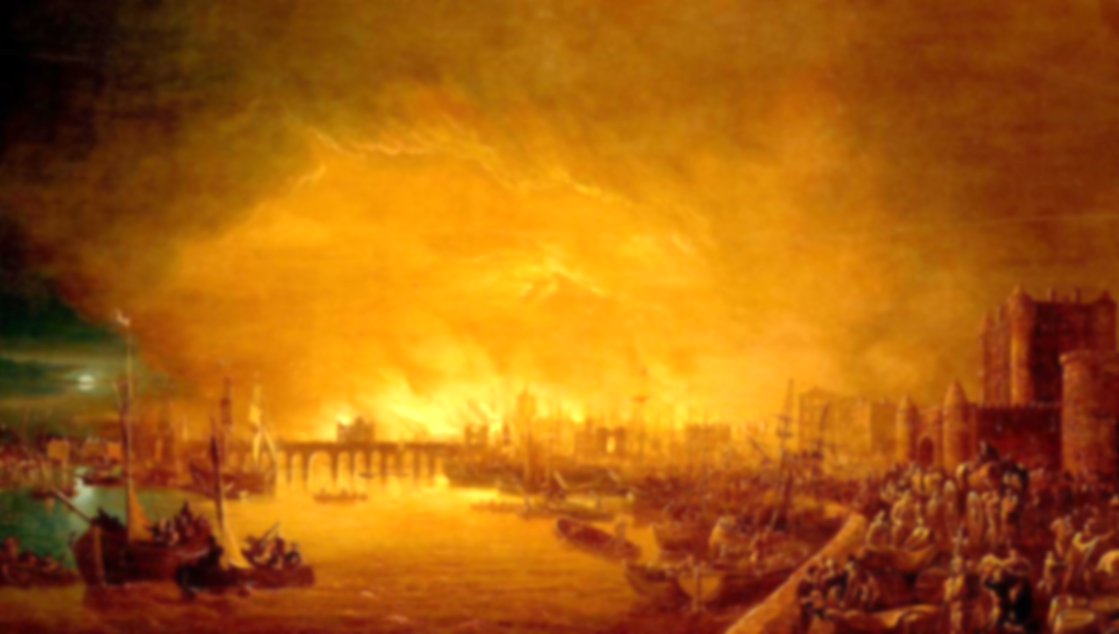
Vocabulary
Century: 100 years
Eyewitness: a person who has seen something happen
Significant: important or noteworthy
Source: something where information can be obtained
Plague: a highly contagious disease
Flammable: easily set on fire
Declaration: a formal statement or announcement
Architect: someone who designs buildings
Monarch: the king or queen
Thatch: a roof covering of straw

Learning point 5: What lessons have we learned from the Great Fire of London?
To understand key features of events, choosing and using parts of stories and asking and answering questions.
- Elicit the children’s understanding of The Great Fire of London, and the events which led up to it, during it and after it.
- Discuss changes which took place directly afterwards.
- Which of these changes can we still see today?
How did the community of London pull together and support each other during the Great Fire of London?

Learning point 4: What happened after the Great Fire?
To understand some of the ways in which we find out about the past and identify different ways in which it is represented.
- What measures were put in place to stop the fire spreading?
- Should London be built the same as it was before?
- Hotseat King Charles II on his plans for London after the fire.
What should King Charles II do differently when rebuilding London?
Learning point 3: How do we know about the Great Fire of London?
To understand some of the ways in which we find out about the past and identify different ways in which it is represented.
- Use paintings and Samuel Pepys’ diary to learn more about the fire.
- Discuss the reliability of different sources of information.
Is Samuel Pepys’ diary a reliable source?
Learning point 2: Events leading up to the fire.
To know and understand key features of an event beyond living memory that are nationally significant.
- Order the events of the Great Fire of London on a timeline.
- Understand the cause of the fire and how it spread so rapidly.
Was the fire started through a lack of responsibility?
Learning point 1: Life in 17th Century England.
I can identify differences and similarities between ways of life in different periods (now and 1666).
- Explain how people live now is different to how people lived in 1666 by looking at jobs/roles in daily life.
- Use sources (paintings) to notice differences in buildings.
- Think about living conditions – diseases, dirt, plague doctors, rats, etc.
How was life in 1666 different to today?

Key Concepts
- Community: a group of people living in the same place or having a particular characteristic in common.
- Culture: the arts, ideas, customs, and social behaviour of a particular people or society.
Fire! Fire!
The Great Fire of London
Previous Knowledge
- Understand family and the people around you.
- Used art as a way of communication.
- Understand that we follow rules or behave in a certain way in different situations.

