- paper
- cardboard
- squashing
- bending
- twisting
- stretching
- waterproof

Key concept vocabulary:
- wood
- metal
- plastic
- glass
- brick
- rock
Prior knowledge / understanding:
- Playing with materials in EYFS.
- Water play in EYFS (what can carry the water).
- Junk modelling in EYFS.
- Discussions about clothing suitability.

Year 1/2 Science KCV
Uses of Everyday Materials
Later learning:
- Year 3/4 : Rocks, States of Matter
- Year 5/6: Properties and Changes of Materials, Earth and Space.

Key knowledge and outcomes: Children will be able to…
- Identify and name everyday materials.
- Identify different uses of everyday materials.
- Record their observations.
- Demonstrate and explain how shapes of objects made from some materials can be changed.
- Explain what recycling means.

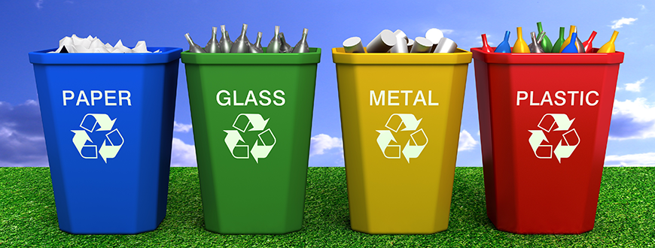

Key assessment questions:
- Can you design a new material?
- Explain how recycling helps the environment.
- Topic link: What materials helped the Great Fire of London to spread?
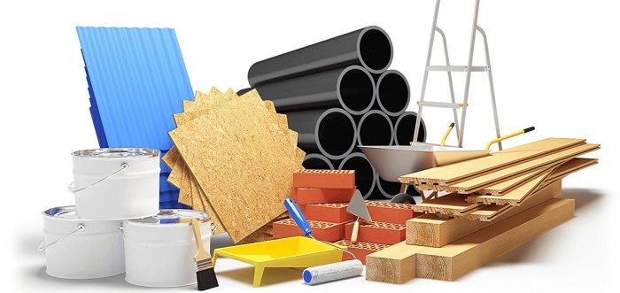

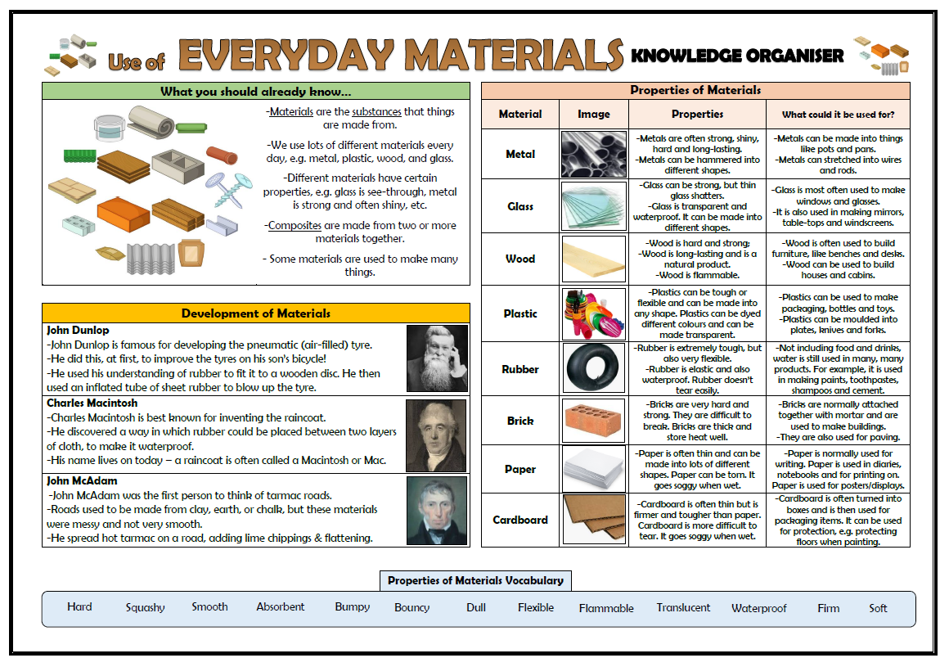
Useful links/resources:
- https://www.stem.org.uk/resources/community/collection/12724/year-2-uses-everyday-materials
- https://www.hamilton-trust.org.uk/science/year-2-science/everyday-materials-materials-matter/
- https://www.twinkl.co.uk/resource/tp-sc-60-planit-science-y2-uses-of-everyday-materials-unit-pack
Books:



